N-gonal Trapezohedron

Definition
# Source: AI Source: Provided by: [Data Path: Persons Table -> ID Column: 1, Name_En Column: Motasem Essam] -> From: [ChatGPT] on [7/25/2026]
An N-gonal Trapezohedron is a convex polyhedron consisting of 2n congruent kite-shaped faces, arranged symmetrically around a central axis.
It has two opposite apexes, one at the top and one at the bottom, connected through two staggered rings of vertices. Each apex is surrounded by $n$ kite-shaped faces.
The N-gonal Trapezohedron is also called an N-gonal Deltohedron. It is the dual polyhedron of an N-gonal Antiprism.
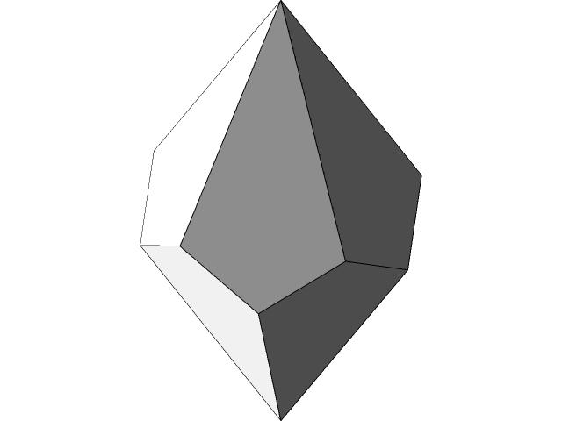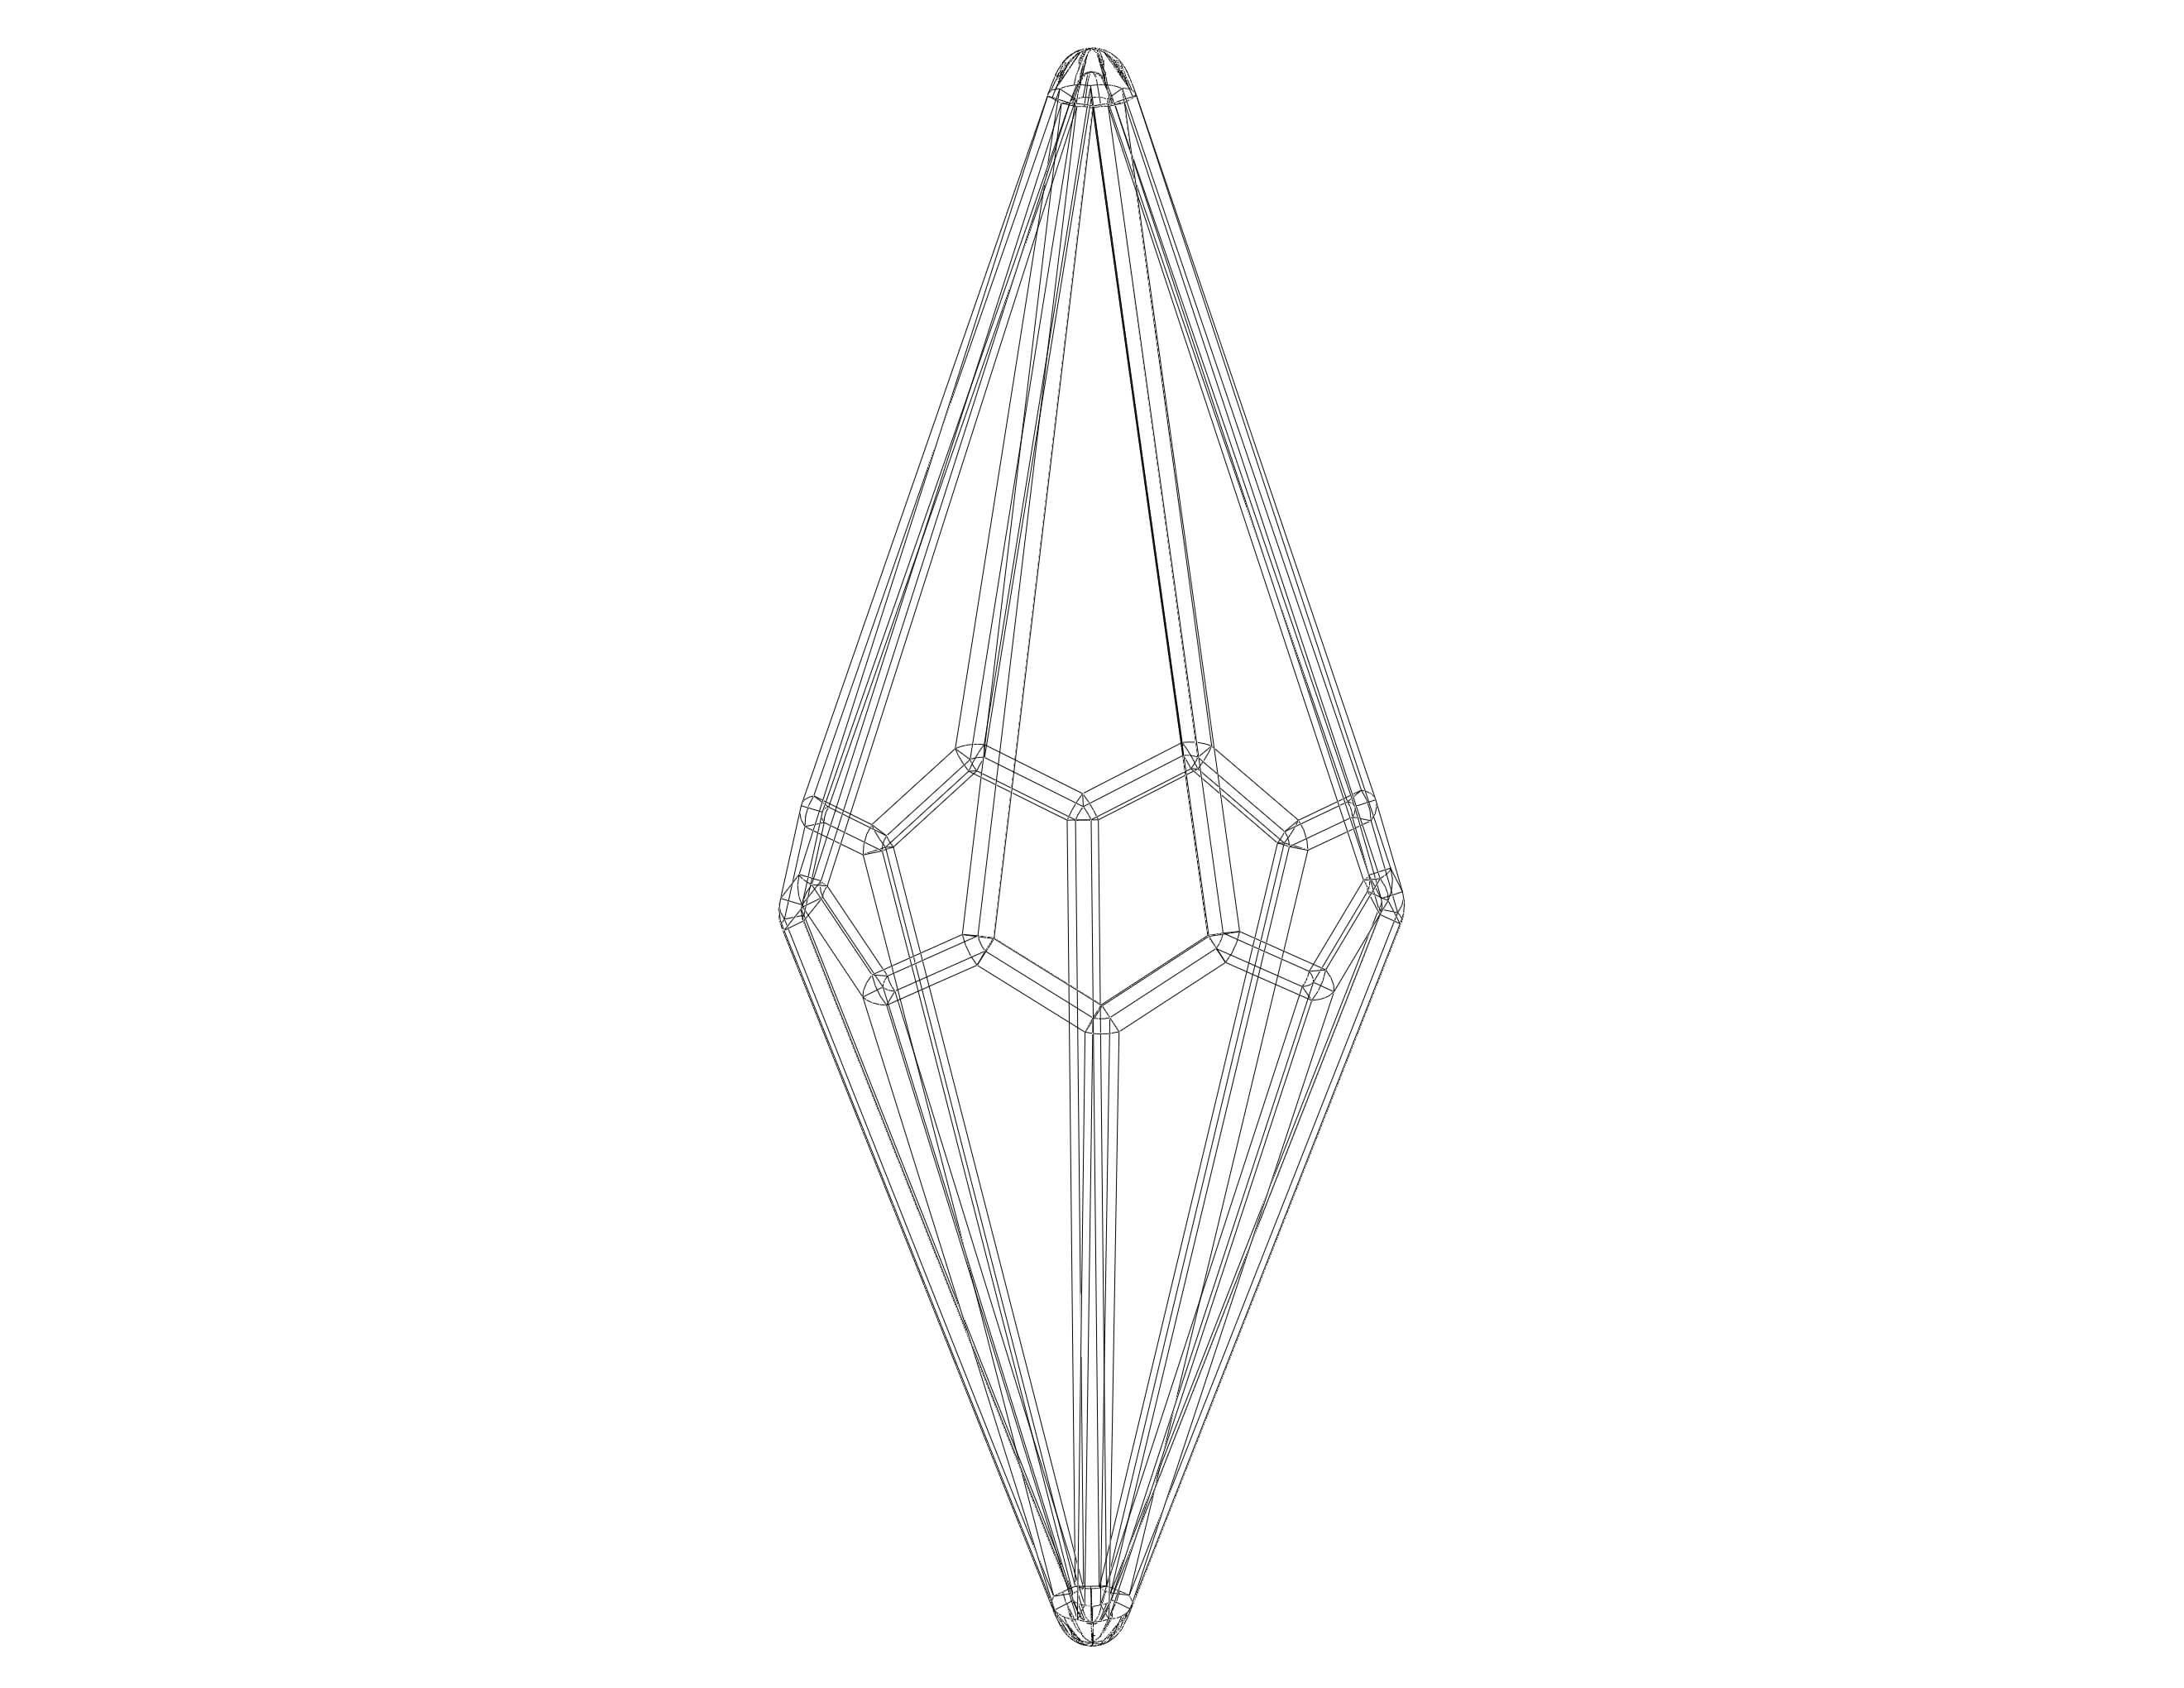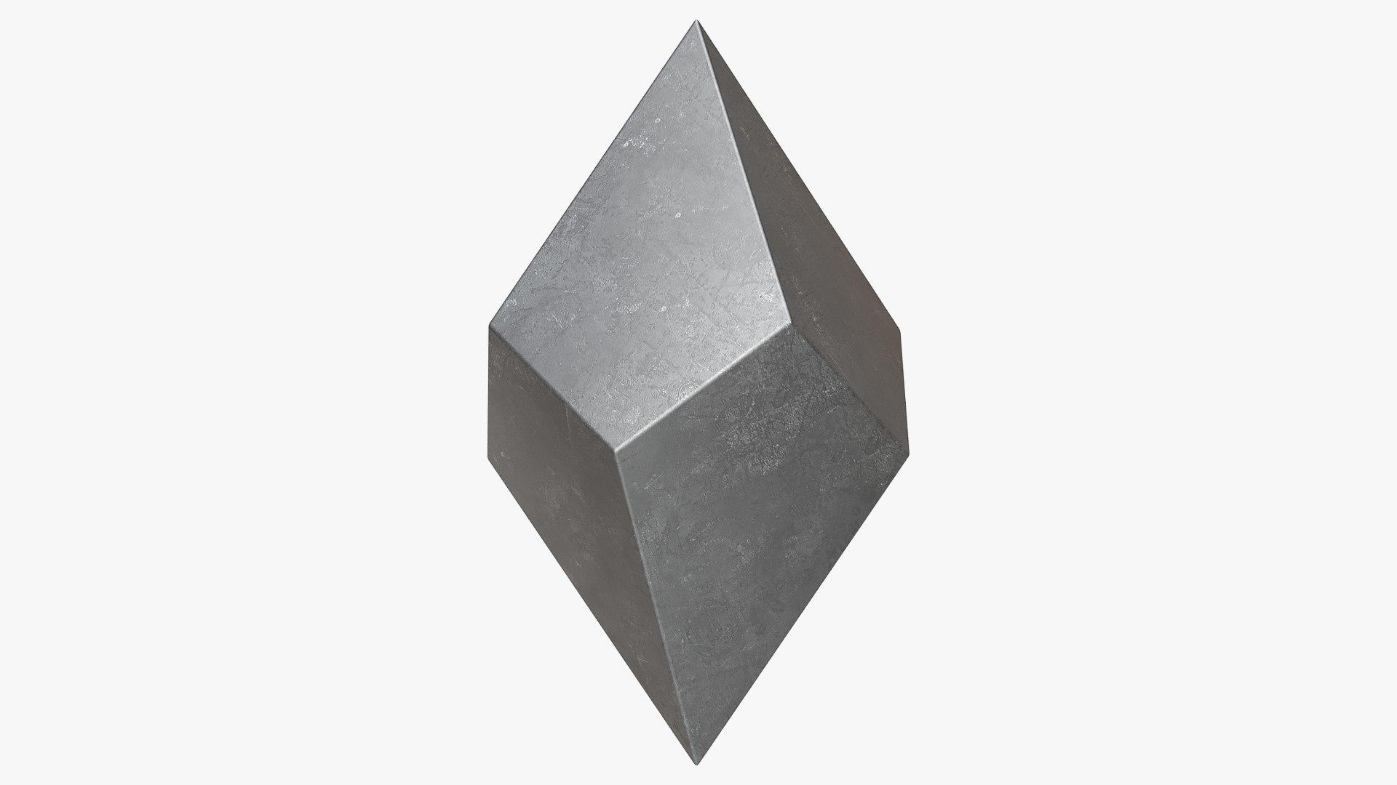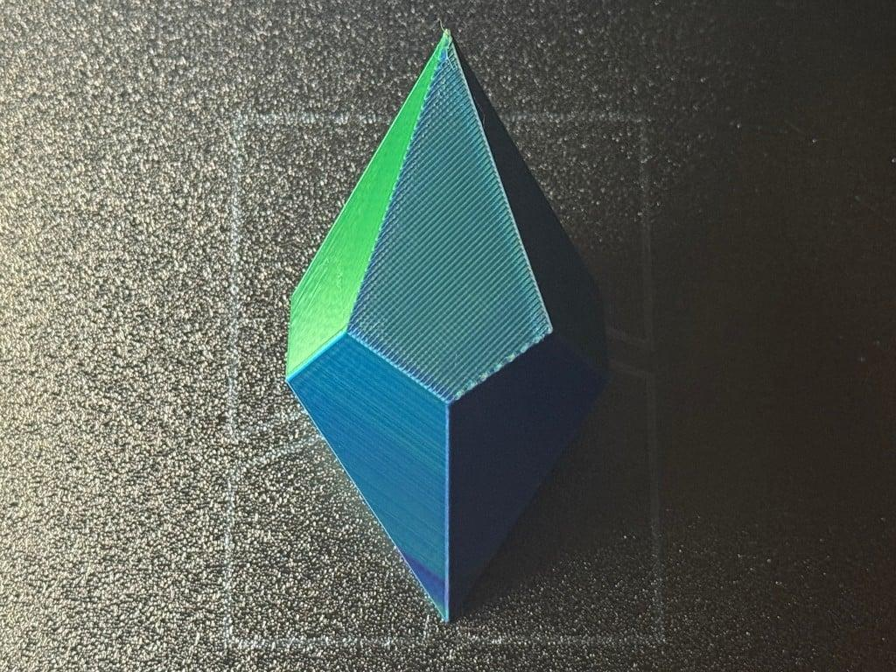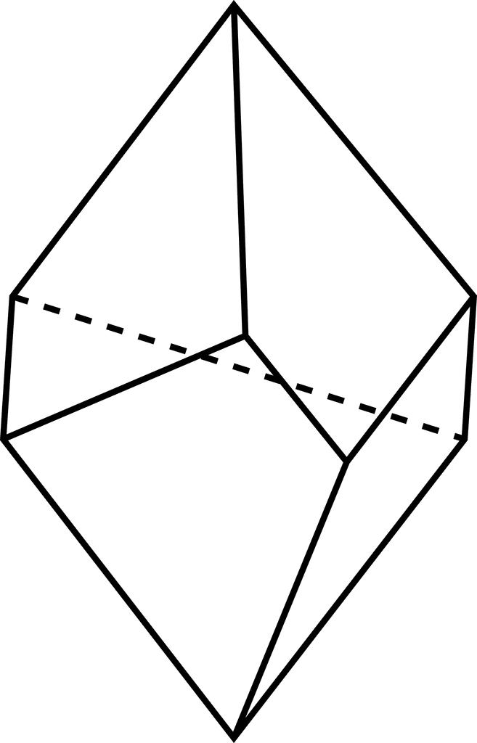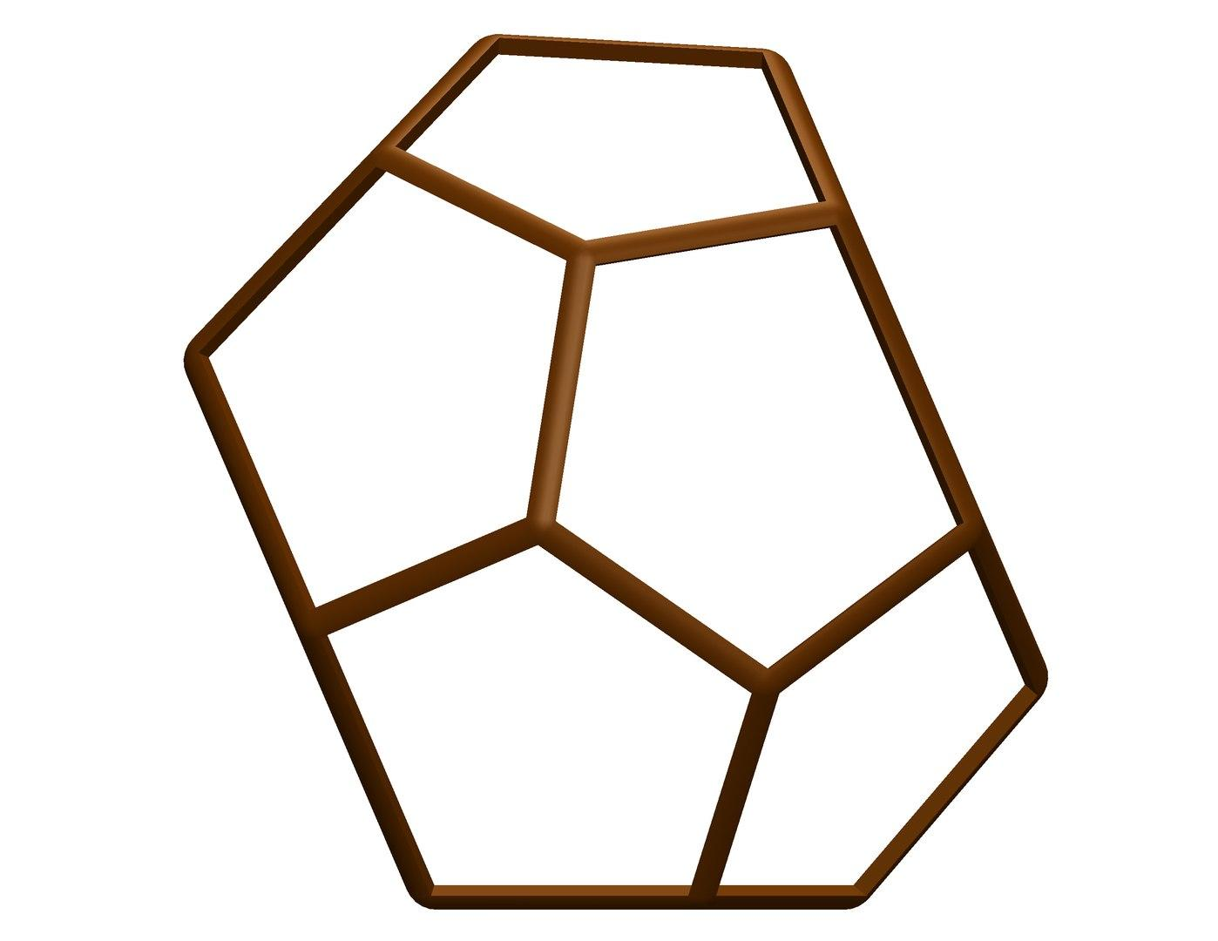

Simple Definition
# Source: AI Source: Provided by: [Data Path: Persons Table -> ID Column: 1, Name_En Column: Motasem Essam] -> From: [ChatGPT] on [7/25/2026]
An N-gonal Trapezohedron is a solid with:
- $2n$ congruent kite-shaped faces.
- $4n$ edges.
- $2n+2$ vertices.
- Two opposite apexes.
- Two staggered rings of $n$ vertices each.
- An $n$-fold rotational arrangement around its central axis.
Here, $n$ represents the number of sides in the corresponding polygonal arrangement.

Geometric Structure
# Source: AI Source: Provided by: [Data Path: Persons Table -> ID Column: 1, Name_En Column: Motasem Essam] -> From: [ChatGPT] on [7/25/2026]
An N-gonal Trapezohedron consists of four main structural elements:
- Upper Apex: The pointed vertex at the top of the solid.
- Lower Apex: The pointed vertex at the bottom of the solid.
- Upper Vertex Ring: A ring containing $n$ vertices.
- Lower Vertex Ring: Another ring containing $n$ vertices, staggered relative to the upper ring.
The two apexes are positioned along the central axis. The two vertex rings are arranged between them, creating a twisted geometric structure.
The kite-shaped faces connect the apexes to the vertices of the two rings.

Face Structure
# Source: AI Source: Provided by: [Data Path: Persons Table -> ID Column: 1, Name_En Column: Motasem Essam] -> From: [ChatGPT] on [7/25/2026]
An N-gonal Trapezohedron has:
$$\boxed{F=2n}$$
congruent kite-shaped faces.
Each face is a quadrilateral with two pairs of adjacent equal sides.
The faces are divided into two groups:
- $n$ upper kite-shaped faces surrounding the upper apex.
- $n$ lower kite-shaped faces surrounding the lower apex.
Each upper face connects to the lower portion of the solid, producing a twisted arrangement.
Important: Despite the name trapezohedron, its faces are kites, not trapezoids.
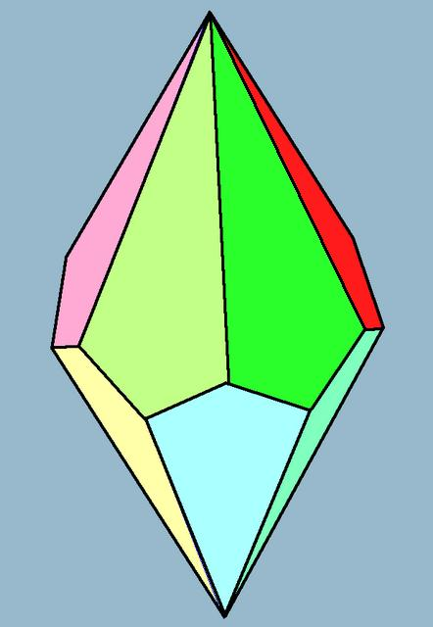

Edge Structure
# Source: AI Source: Provided by: [Data Path: Persons Table -> ID Column: 1, Name_En Column: Motasem Essam] -> From: [ChatGPT] on [7/25/2026]
An N-gonal Trapezohedron has:
$$\boxed{E=4n}$$
edges.
The edges form the boundaries of the kite-shaped faces.
In the standard symmetric form, the edges can be grouped into two categories:
- $2n$ edges of one length.
- $2n$ edges of another length.
Each edge is shared by exactly two faces.

Vertex Structure
# Source: AI Source: Provided by: [Data Path: Persons Table -> ID Column: 1, Name_En Column: Motasem Essam] -> From: [ChatGPT] on [7/25/2026]
An N-gonal Trapezohedron has:
$$\boxed{V=2n+2}$$
vertices.
The vertices are divided into three groups:
- Upper Apex: 1 vertex.
- Lower Apex: 1 vertex.
- Upper and Lower Rings: $2n$ vertices in total.
Each apex is shared by $n$ kite-shaped faces.
Each of the $2n$ ring vertices is shared by exactly 3 faces.
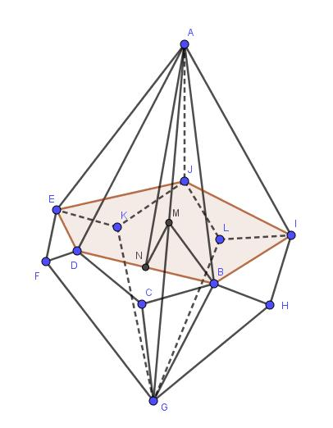

Mathematical Properties
# Source: AI Source: Provided by: [Data Path: Persons Table -> ID Column: 1, Name_En Column: Motasem Essam] -> From: [ChatGPT] on [7/25/2026]
The mathematical properties of an N-gonal Trapezohedron can be expressed using the variable $n$.
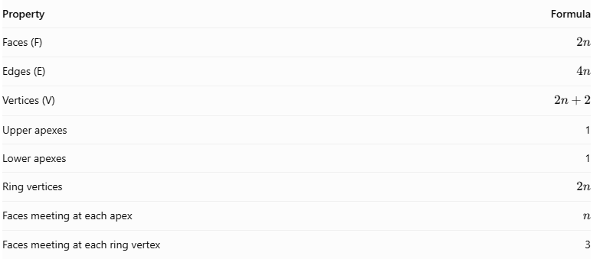
Property | Formula
Faces (F) | $$2n$$
Edges (E) | $$4n$$
Vertices (V) | $$2n+2$$
Upper apexes | 1
Lower apexes | 1
Ring vertices | $$2n$$
Faces meeting at each apex | $$n$$
Faces meeting at each ring vertex | 3
Euler's Formula
Every convex polyhedron satisfies:
$$V-E+F=2$$
Substituting the N-gonal Trapezohedron formulas:
$$(2n+2)-4n+2n=2$$
$$\boxed{2=2}$$
Therefore, the N-gonal Trapezohedron satisfies Euler's formula.

Face Incidence
# Source: AI Source: Provided by: [Data Path: Persons Table -> ID Column: 1, Name_En Column: Motasem Essam] -> From: [ChatGPT] on [7/25/2026]
Face incidence describes how the faces meet at the vertices.
An N-gonal Trapezohedron has two different vertex arrangements:
At the Upper and Lower Apexes:
- $n$ kite-shaped faces meet at each apex.
At Each Ring Vertex:
- Exactly 3 kite-shaped faces meet at each vertex.
Since all faces are quadrilaterals, the vertex configurations are:
- At each apex: $4^{n}$.
- At each ring vertex: $4.4.4$.

Surface Area and Volume

Surface Area
# Source: AI Source: Provided by: [Data Path: Persons Table -> ID Column: 1, Name_En Column: Motasem Essam] -> From: [ChatGPT] on [7/25/2026]
The total surface area is the sum of the areas of all $2n$ kite-shaped faces.
The area of a kite is:
$$A_{\text{kite}}=\frac{1}{2}d_{1}d_{2}$$
Therefore:
$$S=2n\left(\frac{1}{2}d_{1}d_{2}\right)$$
$$\boxed{S={nd}_{1}d_{2}}$$
Where:
- $S$ = Total surface area.
- $n$ = Number of sides in the polygonal arrangement.
- $d_{1}$ = First diagonal of one kite-shaped face.
- $d_{2}$ = Second diagonal of one kite-shaped face.
This formula assumes all $2n$ kite-shaped faces are congruent.

Volume
# Source: AI Source: Provided by: [Data Path: Persons Table -> ID Column: 1, Name_En Column: Motasem Essam] -> From: [ChatGPT] on [7/25/2026]
The volume depends on the dimensions and geometric arrangement of the solid.
It can be calculated by decomposing the trapezohedron into smaller pyramidal or other suitable geometric components.
For a pyramid:
$$V=\frac{1}{3}Bh$$
Where:
- $B$ = Area of the base.
- $h$ = Perpendicular height.
The number of sides $n$ alone is not enough to determine the volume.

Symmetry
# Source: AI Source: Provided by: [Data Path: Persons Table -> ID Column: 1, Name_En Column: Motasem Essam] -> From: [ChatGPT] on [7/25/2026]
The standard symmetric N-gonal Trapezohedron has the following symmetry properties:
- Rotational Symmetry: It has $n$-fold rotational symmetry around its central axis.
- Vertical Reflection Symmetry: It has vertical reflection planes in its regular symmetric arrangement.
- Horizontal Reflection Symmetry: The upper and lower portions can be mirror images across a central horizontal plane.
- Central Symmetry: The standard arrangement has central symmetry when $n$ is even.
The exact symmetry group depends on the geometric realization and arrangement of the solid.
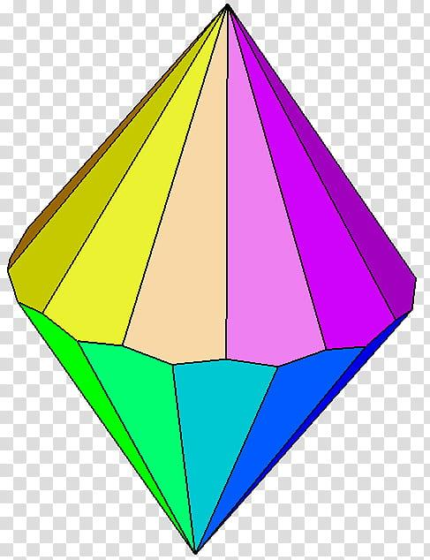

Relationship to Other Solids
# Source: AI Source: Provided by: [Data Path: Persons Table -> ID Column: 1, Name_En Column: Motasem Essam] -> From: [ChatGPT] on [7/25/2026]
The N-gonal Trapezohedron is closely related to the N-gonal Antiprism through polyhedral duality.
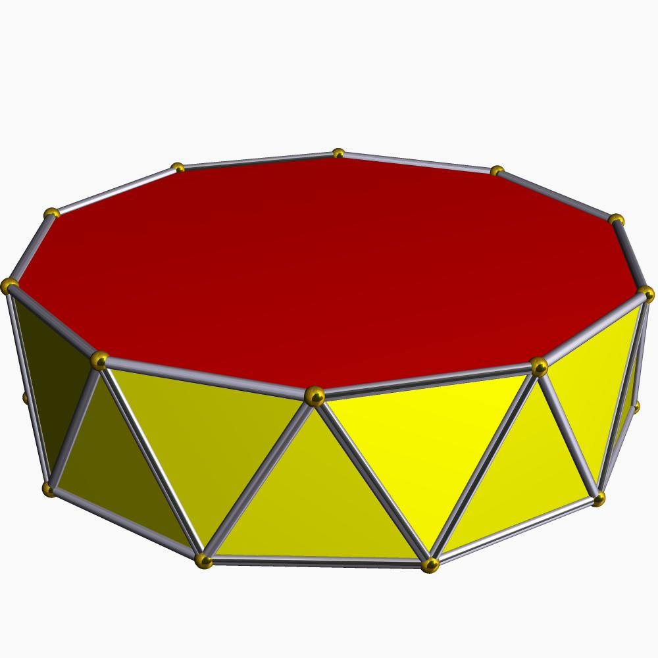
N-gonal Antiprism
Two n-gonal bases and $2n$ triangular lateral faces.
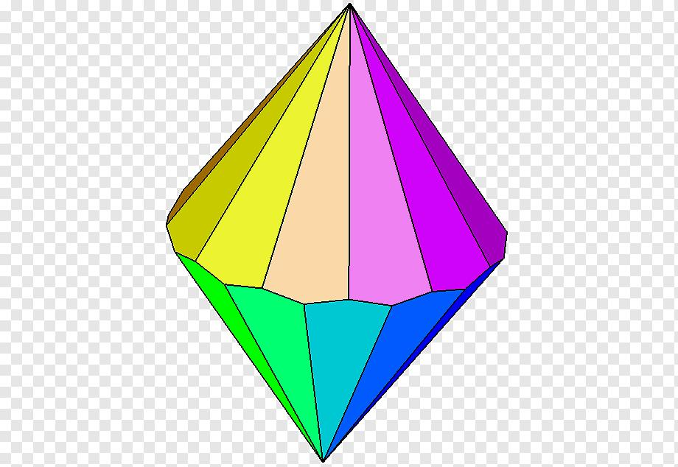
N-gonal Trapezohedron
Two apexes and $2n$ kite-shaped faces.
The N-gonal Trapezohedron is the dual polyhedron of the N-gonal Antiprism.
In this relationship:
- Each face of the antiprism corresponds to a vertex of the trapezohedron.
- Each vertex of the antiprism corresponds to a face of the trapezohedron.
- Each edge of the antiprism corresponds to an edge of the trapezohedron.
The two solids have the same number of edges.

Worked Example
# Source: AI Source: Provided by: [Data Path: Persons Table -> ID Column: 1, Name_En Column: Motasem Essam] -> From: [ChatGPT] on [7/25/2026]
Problem: Find the number of faces, edges, and vertices of a 12-gonal Trapezohedron.
Solution:
Given:
$$n=12$$
Step 1: Calculate the number of faces.
$$F=2n=2(12)$$
$$\boxed{F=24}$$
Step 2: Calculate the number of edges.
$$E=4n=4(12)$$
$$\boxed{E=48}$$
Step 3: Calculate the number of vertices.
$$V=2n+2$$
$$V=2(12)+2$$
$$\boxed{V=26}$$
Final Answer:
- Faces = 24.
- Edges = 48.
- Vertices = 26.

Constructing an N-gonal Trapezohedron in Solid Geometry
# Source: AI Source: Provided by: [Data Path: Persons Table -> ID Column: 1, Name_En Column: Motasem Essam] -> From: [ChatGPT] on [7/25/2026]
Required Instruments:
- Ruler.
- Compass.
- Protractor.
- Pencil.
- Drawing paper.
Construction Steps:
- Choose the value of $n$, representing the number of sides in the polygonal arrangement.
- Draw two regular $n$-sided vertex rings.
- Position the second ring in a staggered arrangement relative to the first.
- Mark an upper apex above the center of the rings.
- Mark a lower apex below the center of the rings.
- Connect the upper apex to the appropriate vertices of both rings.
- Connect the lower apex to the appropriate vertices of both rings.
- Complete the arrangement of $2n$ kite-shaped faces.
- Darken the visible edges and use dashed lines for hidden edges.
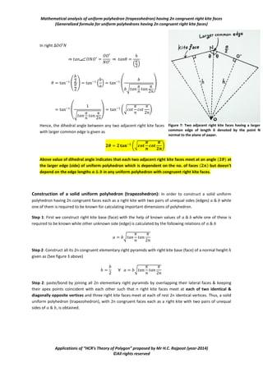

Key Points
# Source: AI Source: Provided by: [Data Path: Persons Table -> ID Column: 1, Name_En Column: Motasem Essam] -> From: [ChatGPT] on [7/25/2026]
- An N-gonal Trapezohedron is a convex polyhedron.
- It has $2n$ congruent kite-shaped faces.
- It has $4n$ edges.
- It has $2n+2$ vertices.
- It has two opposite apexes.
- It has two staggered vertex rings.
- Each apex is shared by $n$ faces.
- Each ring vertex is shared by 3 faces.
- It has $n$-fold rotational symmetry.
- It is the dual polyhedron of an N-gonal Antiprism.
- Its faces are kites, not trapezoids.

Conclusion
# Source: AI Source: Provided by: [Data Path: Persons Table -> ID Column: 1, Name_En Column: Motasem Essam] -> From: [ChatGPT] on [7/25/2026]
The N-gonal Trapezohedron is a family of convex polyhedra characterized by two opposite apexes, two staggered vertex rings, and $2n$ congruent kite-shaped faces.
Its mathematical structure follows general formulas for faces, edges, and vertices, making it an important family in the study of solid geometry, polyhedral structures, and geometric duality.

